Important Note!
You are entitled to the following medical services if you are a recipient of benefits on the basis of the Asylum Seekers’ Benefit Act (AsylbLG):

Medical and dental treatment of acute illnesses and pain relief (when treatment is absolutely necessary and cannot be delayed)
- Prescription of drugs and medicine
- Referral for treatment by other doctors/physicians
- Referral for treatment in a hospital

Physicians/doctors have been informed and will act accordingly.

Health Card

Valid for doctors and dentists only in Lower Saxony

(valid from 01.01.2017)

Family name:

First name:

Date of birth:

Residence:

File number:

Valid until:

VKNR 10806 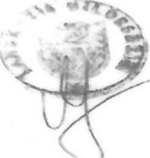
KZVN 34148

The Health Card is only valid for the treatment of acute illnesses and pain relief according to § 4 of the Asylum Seekers’ Benefit Act (AsylbLG) and for screening examinations and vaccinations according to the RL of the GBA.

The treatments to be carried out must be absolutely necessary and need to be undertaken without delay. This does not include chronic illnesses without immediate pain.

The prescription of medical aids and drugs/medicine in excess of € 300.00 requires previous approval. In-patient hospital care, patient transports and dental prostheses are also subject to prior approval.
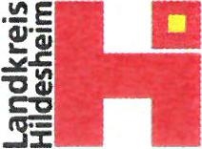

VKNR 10806 KZVN 34148

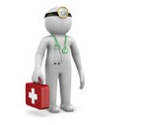
Medical Aid
You will find a list of doctors’ offices in your papers. If you require medical treatment, you can go to one of these doctors’ offices. The doctor will act as your “guide” in coordinating your treatment and will refer you to a specialist or a hospital, if necessary.

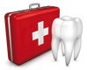
Dental Aid
If you need dental treatment, you can go to a dentist in a dentists’ office. This dentist should be licensed to work together with statutory medical insurance companies.

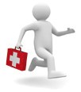
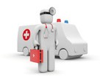
Emergency Medical Services
If you require medical services outside of the regular office hours, you can reach emergency services at the following telephone number: 116 117. This call is free of charge. If your child is ill, dial 05121-894 20 20

Rescue Services in Acute, Life-Threatening Emergencies
If you require assistance in an acute, life-threatening situation, call the following emergency number: 112. This call is free of charge.

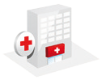
Hospital Treatment
A hospital offers in-patient care to sick people. Treatment in a hospital must be prescribed by a doctor.

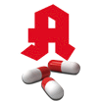
Drugs/Medicine
If you need drugs/medicine prescribed by a doctor, take your prescription to a pharmacy.
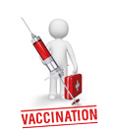
You can also buy over-the-counter medication without a prescription at your own expense.

Vaccinations
Vaccinations protect not only the vaccinated person from infectious/contagious diseases. Vaccinations should be started early. Ask your doctor for more information on vaccinations.

